**Name of the College: NIIT R.G.P.G College Meerut **

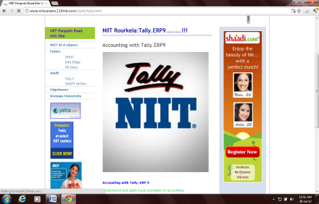 Student Name:________________________________Reg no:________________________

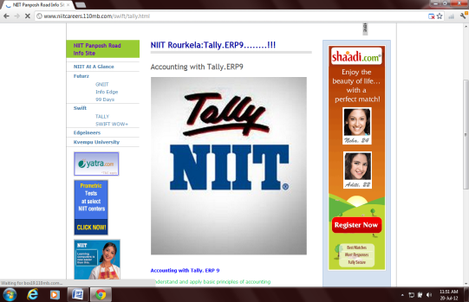 Class:______________Date:_________________Time:30 Min Max Marks: 100 Marks **Set-3**

**QUALIFYING EXAM OF TALLY**

|  |  |  |  |  |  |  |  |
| --- | --- | --- | --- | --- | --- | --- | --- |
| SN | QUESTION_STATEMENT | ANS_A | ANS_B | ANS_C | ANS_D | ANS_E | Ans |
| 1 | A Voucher Types can be created | from scratch | based on existing voucher type | Either A or B | None of these |  | b |
| 2 | Budget activation option is available under | F12 | F11 | Company Alteration | Company Info |  | b |
| 3 | Modifications / alterations if any done by the user in the entries of a Company to trace out them you have to use | Tally Vault | Tally Audit feature | Audit Trail | Any one of them | None of these | b |
| 4 | Deferred Revenue Expenditure group falls under | Branch / Divisions | Indirect Expenses | Direct Expenses | Miscellaneous Expenses | None of these | d |
| 5 | Can we mention narration against each ledger while passing the voucher entry ? | yes | no |  |  |  | a |
| 6 | Unconventional voucher means | Accounting voucher | Inventory voucher | Non accounting vouchers | Banking voucher | Contra voucher | c |
| 7 | The Option - Use Tracking Numbers - is used for. | Sales Challan | Purchase Challan | Purchase Order | Sales Order | Both A & B | e |
| 8 | Which is not a Final Report of a Company? | Balance Sheet | Profit and Loss | Day Book | None of them |  | c |
| 9 | The option - Track Additional cost of Purchase - is used in | Sales | Purchase | Party Receipt | Party Payment |  | b |
| 10 | Salary paid to employees without any value this entry passed through | a) Payment | b) Payment after activate the option from F11 | c) Not possible | d) Received after active the option from F11 |  | c |
| 11 | To switch between Accounts Voucher to Inventory Voucher press | F11 | F12 | F1 for Accounts | Alt+F1 for Inventory | Both C and D | e |
| 12 | The ledger salary payable falls under the group | a) Current liabilities | b) Duty and taxes | c) Loan liabilities | d) All of the above |  | a |
| 13 | Budgets can be of | 2 types | 5 types | 7 types | 3 types | 4 types | a |
| 14 | To feed Free quantities of goods during Sales / Purchase turn on the option | Allow Invoicing | Use different Actual & Billed Qty | Allow 0 (zero) valued entries in Vouchers | Separate Discount column on Invoices | None of these | b |
| 15 | To see the Trial Balance choose | Gateway of Tally > Display > Trial Balance | Gateway of Tally >Trial Balance | Company Info > Trial Balance | None of these |  | a |
| 16 | "The shortcut key ""to remove a line in a report"" is" | a) Ctrl + R | b) Alt + L | c) Alt + R | d) Either (a) or (b) |  | c |
| 17 | Credit Note is associated with | Sales Challan | Sales Return | Purchase Challan | Purchase Return | None of these | b |
| 18 | To see the Balance Sheet in a detailed manner What is the Shortcut Key ? | Alt+F2 | F2 | Alt+F1 | F12 (Configuration) |  | c |
| 19 | Which one is the right VAT adjustment entry | a) Output VAT A/C Dr to Input VAT A/C to Vat payable | b) VAT payable A C Dr to Bank | c) Bank A C Dr to VAT payable | d) VAT payable A C Dr to Input VAT to Output VAT |  | a |
| 20 | F11 refers to sales order | TRUE | FALSE |  |  |  | b |
| 21 | What is the difference between Indirect Expenses and Expenses (Indirect) groups? | They are two separate primary groups | Indirect Expenses is an alias of Expenses (Indirect) group | Expenses (Indirect) is an alias of Indirect Expenses group | A and B | B and C | c |
| 22 | In a Company we may maintain | Accounts only | Accounts with Inventory | Both of these | Either of these | None of these | c |
| 23 | Price List is applicable in case of | Delivery Note | Receipt Note | Purchase Order | Purchases |  | a |
| 24 | In price list we show | Trade Discoiunt | Cash discount | both a & b | none of these |  | a |
| 25 | For Calculation purpose which key we will use ? | Alt+C | Alt+N | Alt+M | All of these |  | a |
| 26 | Stock journal can be used as | manufacturing voucher | transfer of materials | both a & b | none of these |  | c |
| 27 | toggle button between optional & regular voucher | a) alt + L | b) ctrl + L | c) ctrl + v | d) Alt + O |  | b |
| 28 | Expenses or Fixed Asset are allowed in Purchase Vouchers ? | True | False |  |  |  | a |
| 29 | Expiry dates for an item like Medicine can be given in Tally | True | FALSE | - | - |  | a |
| 30 | Directory where TallyProgram Files will be Loaded is | Tally Directory | Application Directory | Data Directory | All of these | None of These | b |
| 31 | Is it necessary to give Chalan No in - Reference - | True | False |  |  |  | b |
| 32 | You can press ______on payslip screen to change configuration | a) F12 | b) F11 | c) Alt + F12 | d) Ctrl + F11 |  | a |
| 33 | To Select an existing company the way you should follow | Gateway of Tally >Company | Company Info >Select Company | Company Info > Company | Any one of them | None of these | b |
| 34 | Cost Category is essential to prepare Cost Centre. | True | False |  |  |  | b |
| 35 | The shortcut key used for Memorandum Voucher | Ctrl+F10 | F10 | Ctrl+F8 | Ctrl+F9 |  | a |
| 36 | Opening Stock and Closing Stock both can be viewed through stock summary | True | False |  |  |  | a |
| 37 | Special journal that automatically reversed after date of journal | Scenario management | Budget | Reversed Journal | Reversing journal | VAT adjustment journal | d |
| 38 | Budget option is available in | Accounts Info | Inventory Info | Both A & B | Not Available |  | a |
| 39 | If you want to change the view of voucher entry screen from Dr Cr mode to To By mode use | company features | Company configuration | gateway of tally | company info |  | b |
| 40 | Is there any difference between Reversing Journal and Memorandam Voucher ? | Yes | No |  |  |  | a |
| 41 | Is it possible to pass a payment entry in single entry mode ? | yes | no |  |  |  | a |
| 42 | How to create Employee Group in Tally | a) GOT> Payroll voucher> Employee | b) GOT> Payroll info> Employees | c) GOT> Payroll info> Employee | d) None of these |  | b |
| 43 | Shortcut key used to see the report in Detailed Format | Alt+F4 | Alt+F2 | Alt+F5 | Alt+F1 |  | d |
| 44 | Depositing cash to SBI should be passed through | Payment mode | Reciept mode | Contra mode | Purchase | Sales | c |
| 45 | Which key we will use to activate Company features ? | F11 | F4 | F6 | F12 |  | a |
| 46 | Reciept PaymentVouchers can be passed in | Single Entry mode | Contra mode | Double Entry mode | Payment mode | Both A & C | e |
| 47 | Is it possible to record Post-Dated Cash or Bank Transaction? | Yes | No |  |  |  | a |
| 48 | Cash to Bank transaction in Tally can be passed through | Payment Voucher | Contra voucher | Reciept voucher | Voucher Class | None of the above | b |
| 49 | What is the function of alias in Master ? | Shortname | Full name | Address | None |  | a |
| 50 | There are ________ types of Unit of measurements | 1 | 2 | 3 | 4 |  | b |